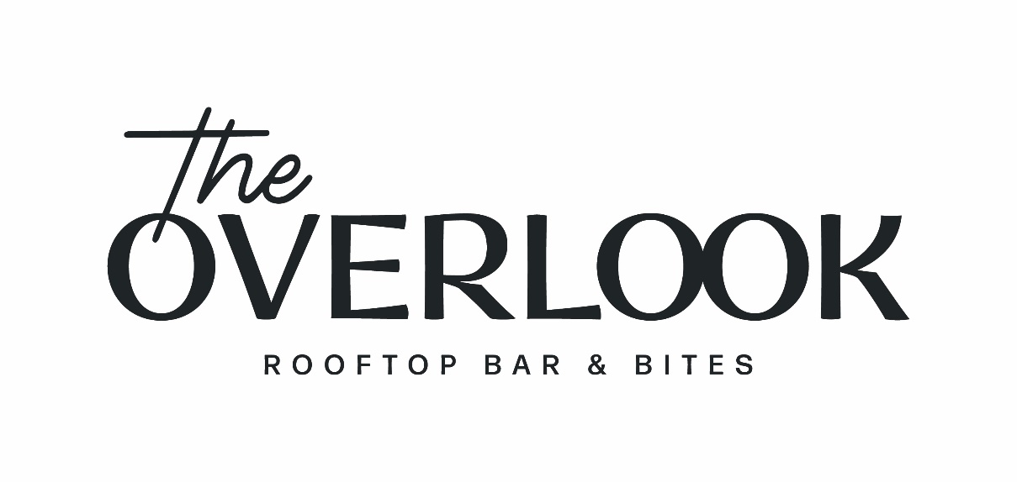
LIVE MUSIC SCHEDULE

MAY
May 11 – Emily Ortego
May 12 – Jenny Rae
May 13 – Kobe Miyake
May 18 – Kierra Carson
May 19 – Kobe Miyake
May 20 – Emily Ortego
May 25 – SONGWRITERS NIGHTS
May 26 – Rebecca Brunner
May 27 – Kobe Miyake

JUNE
June 1 – Jenny Rae
June 2 – W.B. Sims
June 3 – Cody Knapp
June 8 – Jed Harrelson
June 9 – Rebecca Brunner
June 10 – Gabriel Broussand
June 15 – Rebecca Brunner
June 16 – Jade Million
June 17 – Rebecca Brunner
June 22 – Ryan Yingst
June 23 – Jade Million
June 24 – Wyatt Edmondson
June 29 – Wyatt Edmondson
June 30 – Wyatt Edmondson

